TITLE OF PAPER
(SEGOE UI, 12 PT, ALL CAPS)

A.B. AUTHOR¹, C.D. AUTHOR² (11 PT, ALL CAPS)

¹Department, Organisation, City, Country (10 pt, italics)
²Department, Organisation, City, Country (10 pt, italics)

Your abstract must be written here. It can take maximum 10 lines.
The font throughout the text is Segoe UI and the font size is 10 pt. Setting of paper size is DINA4-size. The top, left, right and bottom margins are 2.5 cm. For the abstract paragraph the left and right margin are 3.5 cm.
Single line spacing with a spacing of 0 pt before and after the paragraph mark, and the lines are justified in block mode.

Introduction (11 pt, bold)

Settings

Your abstract must be written here. It can take maximum 10 lines.
The font throughout the text is Segoe UI and the font size is 10 pt. Setting of paper size is DINA4-size. The top, left, right and bottom margins are 2.5 cm. For the abstract paragraph the left and right margin are 3.5 cm.
Single line spacing with a spacing of 0 pt before and after the paragraph mark, and the lines are justified in block mode.

Figures and tables

Figures and tables should be inserted into the text at the appropriate place. They should be clearly identified with a caption and centred, as shown below.

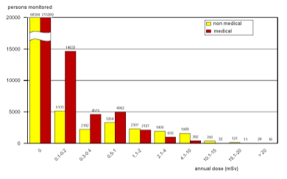
Figure 1. Caption for figure one (italic 9 pt).

Table 1: Caption for table one.
xxx | yyy | zzz
aaa | 123 | 456
bbb | 789 | 012
ccc | 345 | 678
ddd | 901 | 234

Electronic form of contribution

For the conference proceedings (Transactions) an electronic version as a MS WORD.docx file of your final paper is required.

Length of your paper

We recommend a standard length of your manuscript of five to ten pages, including the title page, all tables and figures and the references.

References

Please number your references and cite them in brackets [1]. The list of references should be at the very end of your paper under the section heading “References”.

Deadline

Your full paper must be sent by March 31, 2021 the latest to academy@sckcen.be.

Contact

Please do not hesitate to contact the ETRAP 2021 secretariat in case of question via phone +32 14 33 88 51 or email: academy@sckcen.be.

Acknowledgement

This is the place to acknowledge collaborations or sponsors.

References

[1] Reference

